Parts:

-NPK Sensor

-PAR Sensor

-1 Pump

-1 Solenoid valve switch thing

-Arduino MKR WIFI 1010

New NPK Sensor:

[New NPK](https://www.amazon.com/Nitrogen-Phosphorus-Potassium-Conductivity-Temperature/dp/B0BVW1X7VY/ref=pd_sbs_d_sccl_3_4/139-5779354-0263213?pd_rd_w=35lJ6&content-id=amzn1.sym.f7f035a5-ff07-4412-8a3c-9301028ec36b&pf_rd_p=f7f035a5-ff07-4412-8a3c-9301028ec36b&pf_rd_r=C6Q9YFAYVW2DXTT6STY6&pd_rd_wg=QMRs5&pd_rd_r=511a1da6-96ea-4601-a381-08ff5df1f9c0&pd_rd_i=B0BVW1X7VY&psc=1)

Power Supply:

4.5-30VDC

Max Draw:

0.02A at 24V

PAR Sensor:

[Link](https://www.amazon.com/4-20mA-Photosynthetic-Transmitter-Photosynthetically-Pyranometer/dp/B0CBRCSN4P?ref_=ast_sto_dp&th=1)

-7-30VDC

0.06W

Arduino:

-Vin: 5V

-1A max?????******

Pump:

-350mA at 12V

<https://www.amazon.com/dp/B09XH1GYYQ?ref=ppx_yo2ov_dt_b_fed_asin_title>

Pump Connector:

-VH-2Y

-2POS 3.96MM

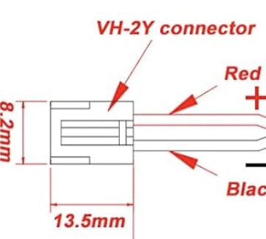

Male Side that we need:

<https://www.digikey.com/en/products/detail/jst-sales-america-inc/B2PS-VH/926555>

-^Order the above

-Using the one below as a placeholder just because the one above isn’t in Altium:

<https://www.digikey.com/en/products/detail/te-connectivity-amp-connectors/647676-2/2299232>

Valve:

-0.17A at 12V

<https://www.amazon.com/dp/B07WRBJDYL?ref=ppx_yo2ov_dt_b_fed_asin_title>

Valve Connector:

Type: 2 Position 3 Way

Connector Pitch : 2.54mm

Port 1, 2, 3 Inner DIameter: 4.5mm

Port 1, 2, 3 Outer DIameter: 7.2mm

-<https://www.digikey.com/en/products/detail/molex/0022053021/26689>

Barrel Jack Connector:

<https://www.digikey.com/en/products/detail/same-sky-formerly-cui-devices/PJ-002BH/408447>

-5A 24VDC rating

Power Supply:

[Amazon Link](https://www.amazon.com/ALITOVE-100-240V-Converter-Available-Security/dp/B07VQGHSWY/ref=sr_1_8?crid=MXAS7AH1PC9H&dib=eyJ2IjoiMSJ9.J8xYKsWv_pVygqEj2wFeDRNOkl_s12BqhSyoPMXhSQpGWHncH8UCIog_mUng4o_thC1RhxBeNodVunt61pGOMhMsQffXDdBcwhAw-Gl5WSB-3DROtw7bePmINCbAN7Y1CWBaWjGKgPak_aY_3i7LmReeRzfEZAarH5k6T52Tj9D4Rwga26IxeoROw8Cp-8i5TyAqr8W68sOMt_wCytPf-6LVtBS9x7y34TJG5OHfSQU.fr5A78bkXH2EIzN5ovT-a0ZmtbA3RzfN2Nv29Lb8iWI&dib_tag=se&keywords=12v%2Bpower%2Bsupply%2B5.5mm%2Bx%2B2.5mm&qid=1730231123&sprefix=12v%2Bpower%2Bsupply%2B2.5mm%2Caps%2C125&sr=8-8&th=1)

* 3A 12V DC

Connector for NPK Power:

<https://www.digikey.com/en/products/detail/w%C3%BCrth-elektronik/691214110002/2508516>

-*******Find 12V to 5V converter that can work on the PCB

-*******Find Relay that may be able to work on the PCB

<https://www.amazon.com/Channel-Optocoupler-Isolated-Control-Arduino/dp/B07XGZSYJV/ref=sr_1_3?crid=1KUQMS7MGST31&dib=eyJ2IjoiMSJ9.3dBSOXrHQ6_mhNepskdlnu7wZKXr90xb7SibQjZLudYuEcpQsg2R3qpoKMeoNc2M4SKK-_FzYlbcHWOwUPb2nJwbGhXFgY3OOw1M_mx-S30Y1zOqJCMMuRXszllLCpe99UdUMTm7Qtol2CPq_4yS2OWL4oMP3_XVrDJA8T0kx13erMw97AXGXs2Q_WlS377Uvt1DYi7EjON8iXSRI8D9PzImj1Q7eJicH07fq8ucehXg9wn7gr4SKLjqc8UiqQiU0jJWkUWSrO0jXeePKBU2WkCO2b3zEYpJr0Klj3QXRBg.8BFOIpgg7is6_CxBwJtiqPWCQ56Kg2IHAvGRaSoZ8-k&dib_tag=se&keywords=3v+relay&qid=1730233300&s=industrial&sprefix=3v+relay%2Cindustrial%2C113&sr=1-3>

Relay Components:

Optocoupler:

[https://www.digikey.com/en/products/d etail/everlight-electronics-co-ltd/EL817/2693260](https://www.digikey.com/en/products/detail/everlight-electronics-co-ltd/EL817/2693260)

-Forward Voltage: 1.2V

—---------------------------------

Approach:

-I can do 2 PCB design versions:

-Lazy / simple solution:

-Basically absolute bare minimum to get wall power working

-Very high chance of working

-Mostly just connectors

-Will mount the relay board(s) to this board

-Professional solution:

-More risk of not working / requiring a revision that we may not have time for

-Have the relay and control signals be directly on-board

-Have the buck converters be directly on-board

-More time with component replacement / selection

-Will require digital vs. power separation.

-I can do both, then ask Cayden what he thinks based on the 2 designs.

—--------------------------------------

Buck Converter 12V to 5V

-MP3610

-1.2A continuous current load

-Powering: Arduino, potentially the logic side of the relays (although that’ll need switching capabilities so a 3.3V GPIO pin it is for that)

-Using a buck converter as opposed to a voltage regulator because it’s more power efficient.

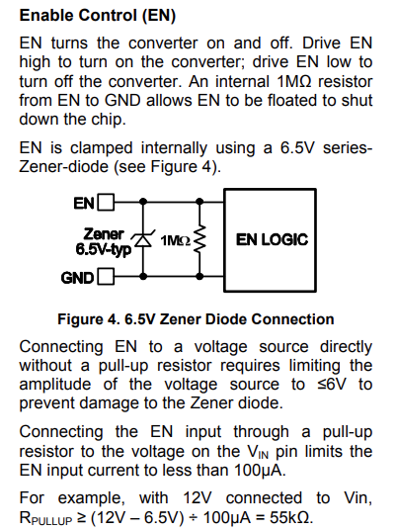

Rpullup = 55kOhm or a bit higher.

-****Large copper plane under the 3 SW pins to “improve thermal performance”

-VCC connection????

-Terminating resistor on Modbus side?***********

-Enclosures with standoffs:

-Add mounting holes to work within

-Clear top to show off the internals

-PAR Sensor outside

-******PAR sensor power

<https://electronics.stackexchange.com/questions/141897/dc-power-supply-jack-connector-pinout>

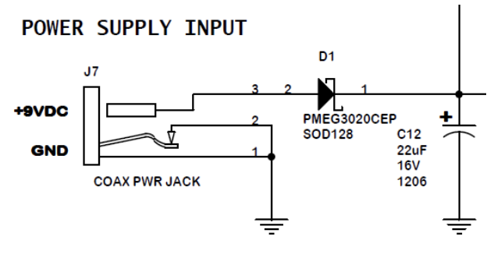

Extremely helpful thread:

<https://www.reddit.com/r/AskElectronics/comments/wteb9w/am_i_connecting_this_barrel_jack_correctly_do_i/>

Takeaways:

-Diodes used to “logically switch the input with a battery without backfeeding the battery (charging a non-rechargeable battery)”

-Since the barrel jack is the only power source in my design, the diodes are not necessary.

-The voltage drop they introduce would potentially be a problem.

-The diode may also be used for polarity protection. Most power supplies are center positive (meaning the center pin of the connector…?) besides guitar pedals.

-The 3rd / middle pin on the barrel jack connector schematic symbol is generally used for battery connection. (I think)

-”Diode is needed if barrel plug can have reversed polarity, which is possible”

-Basically could depend on the device user’s DC converter they’re plugging in. But for our purposes, we can just double check the DC converter to ensure the center pin is positive.

-*****Make sure to test this before buying***********

-The capacitor used is a “bulk capacitor”

-Located near power supply connection point

-Used to overcome the voltage drop caused by the inductive effects of PCB traces

-Also helps with sudden current draw where the voltage would drop (aka the “smoothing” effect of the capacitor pretty sure)

More Info on Reverse Polarity Diode:

<https://www.royalcircuits.com/2019/08/28/the-reverse-polarity-protection-diode/>

-Choose a Schottky diode for reverse polarity protection

-Lower voltage drops

-Better suited for low voltage, low current demand circuits

-Surface mount components apparently lead to cheaper PCBs than through-hole

-Without Schottky, can lose up to 0.7V with other diodes

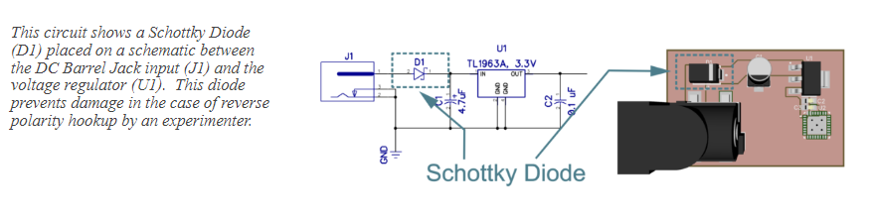

More Info on Bulk Capacitor:

<https://components101.com/articles/decoupling-capacitor-vs-bypass-capacitors-working-and-applications>

-Also called decoupling capacitor (I think)

-Used to filter out noise from the power supply (filters out the AC component)

-Placed in parallel with the power supply and load.

-Decoupling near ICs typically uses 2 caps:

-1 for low frequency noise (1uF to 100uF range)

-1 for high frequency noise (0.01uF to 0.1uF range)

-Specific value in IC datasheet

<https://electronics.stackexchange.com/questions/170957/de-coupling-capacitor-and-bulk-capacitor>

-Bulk cap used to prevent the output of a supply from dropping too far during the periods where current is not available.

-Decoupling caps are typically local to ICs. Typically much smaller than bulk caps because they are intended to supply current for much briefer periods.

-Ex: Used on the buck converter in the design it seems

-Helps maintain voltage when current spikes are present (which will definitely be the case with our pumps)

-******Will need to determine what capacitance to use for the bulk capacitor to handle the changes in current for turning off and on the pumps.

<https://www.ti.com/content/dam/videos/external-videos/en-us/8/3816841626001/6265440667001.mp4/subassets/motor_drivers_voltage_margin_and_bulk_capacitance_precision_labs_1.pdf>

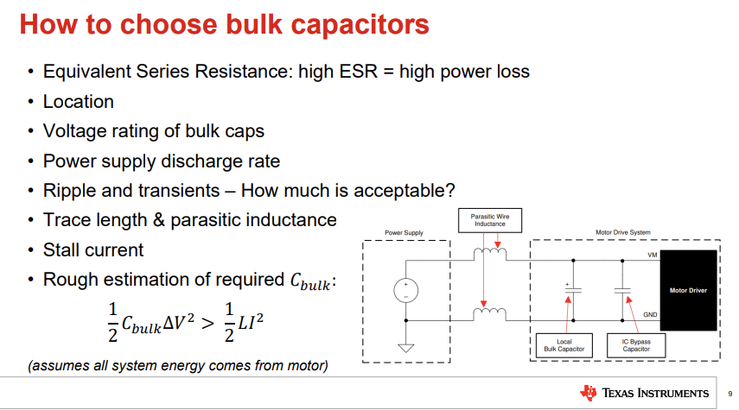

-Not super helpful currently, as I’d need to measure the inductance of the pump and valve.

-I guess a concern is if the voltage dips enough, it could trigger the EN of the buck converter as low

-*****Double check the correct pins are used for 12V vs GND on the connectors***********

-****Flyback diode in parallel with the relay, not the connector********

—-----------------------------------------

11/14/2024 Revisions

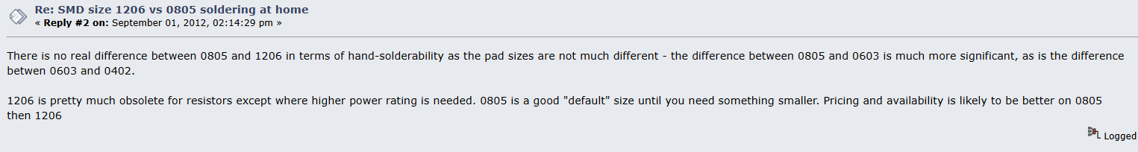

-1206 size for resistors “obsolete”

-0805 standard, good for power, easy to solder by hand. 0603 kinda difficult.

-Buck Converter: What is VCC used for?

-VCC should not be connected. It just has a pin label in the Adafruit schematic.

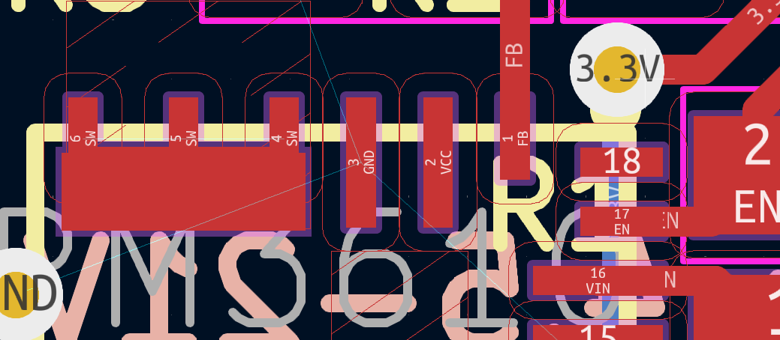

-***Try to show the resistance and capacitance values on the schematic for reference / clarity when presenting****

-I can update this after sending off for production though.

*****MOUNTING HOLES*******

-What screw size to use?

*******Engineering standard to include in design doc:

ASME B18.2.8

-Metric screw hole clearance sizes (used for the power PCB)

<https://amesweb.info/Screws/Metric-Clearance-Hole-Chart.aspx>

Note: Using M2 screw holes

Note: Need to make sure that the board is unplugged from wall power when we program it through USB (because I don’t wanna deal with supporting a simultaneous connection)

Note: For usage, connect the higher current 12V peripherals closer to the connector, and the lower current peripherals further away. (Just the way the layout it set up)

-Since they have dedicated lines to the connector and aren’t on this bus thing the last 3 connectors are on.

-Vias for thermal distribution???

-And should they be connected to the GND net???

-Sounds like vias should be used for thermal distribution directly under components that generate a lot of heat (if you can). For my setup, the vias close to the buck converter should be fine. And as long as we have a short return path on the higher current peripherals, we should be fine thermally I think.

-I think we will have to do a 4-layer with JLCPCB based on their routing size guidelines.

-Also remember to order an extra barrel jack connector, at least 1 extra.

Screw Hole Measurements:

* Relay Board (51x46x19mm): Screw Holes 2.6mm
* RS485 Converter Board (15.6x42.7mm): No Screw Holes
* Ada Fruit Buck Converter (10.2x17.6mm): Screw Holes 2.2mm

PCB Stackup: Copper Layer Weight (thickness):

<https://camptechii.com/a-shortcut-to-understanding-pcb-copper-weight-thickness/#:~:text=Most%20PCBs%20are%20manufactured%20using,stresses%20and%20better%20thermal%20management>

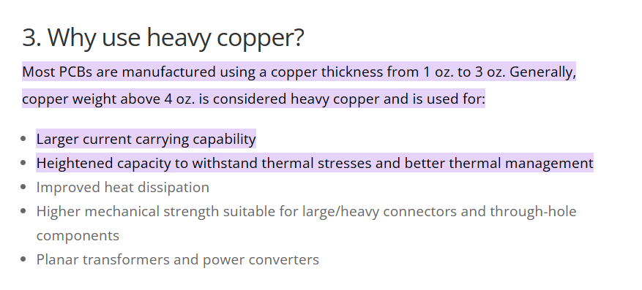

PCB Breakout Version Parameters:

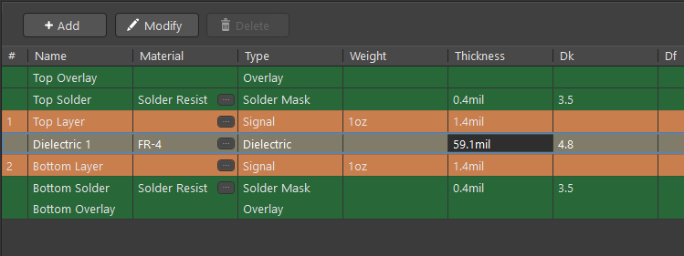

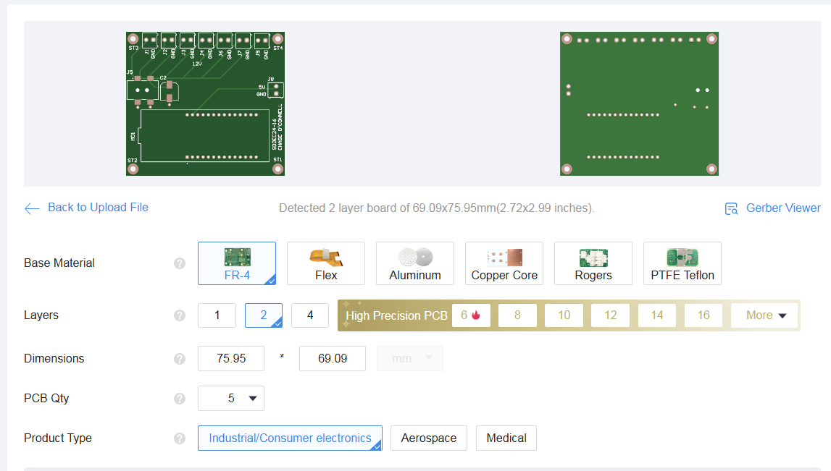

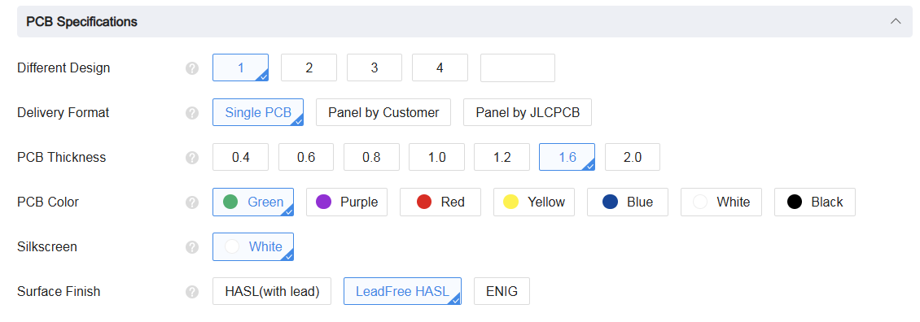

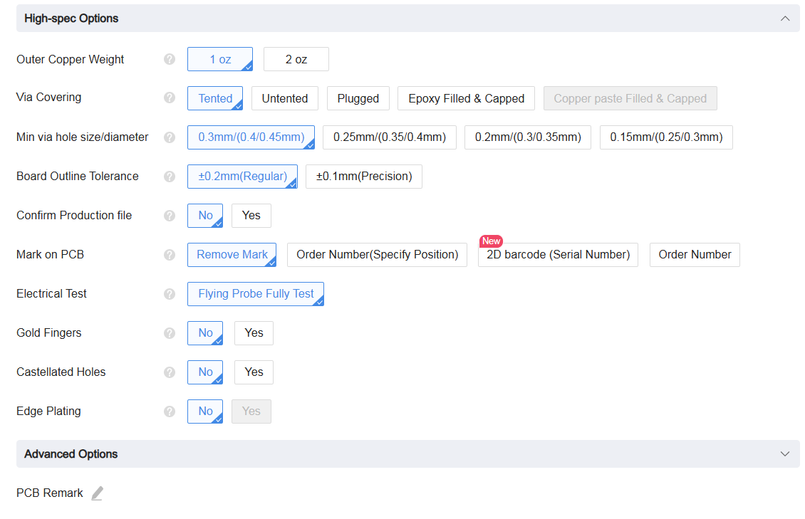

****Lead Free to be RoHS compliant, another engineering standard*****

****DigiKey Cart for PCB Components (Breakout Version):

<https://www.digikey.com/short/v3v8bbv0>